The receiver diversity adapter can be installed with 2 different receivers to achieve redundant operation, intergarting 2 frequency combinations on 1 diversity Rx.

The transmitter diversity adapter can be installed with 2 different transmitter to achieve redundant operation. Transfering the Remote controller signals to each transmitter in the same time, and the telemetry signals from various channels can be integrated to the remote control.

Customized Version: 2RX/2TX. 3RX-4RX-5RX/3TX-4X-5TX Multi-frequency diversity version launch soon.

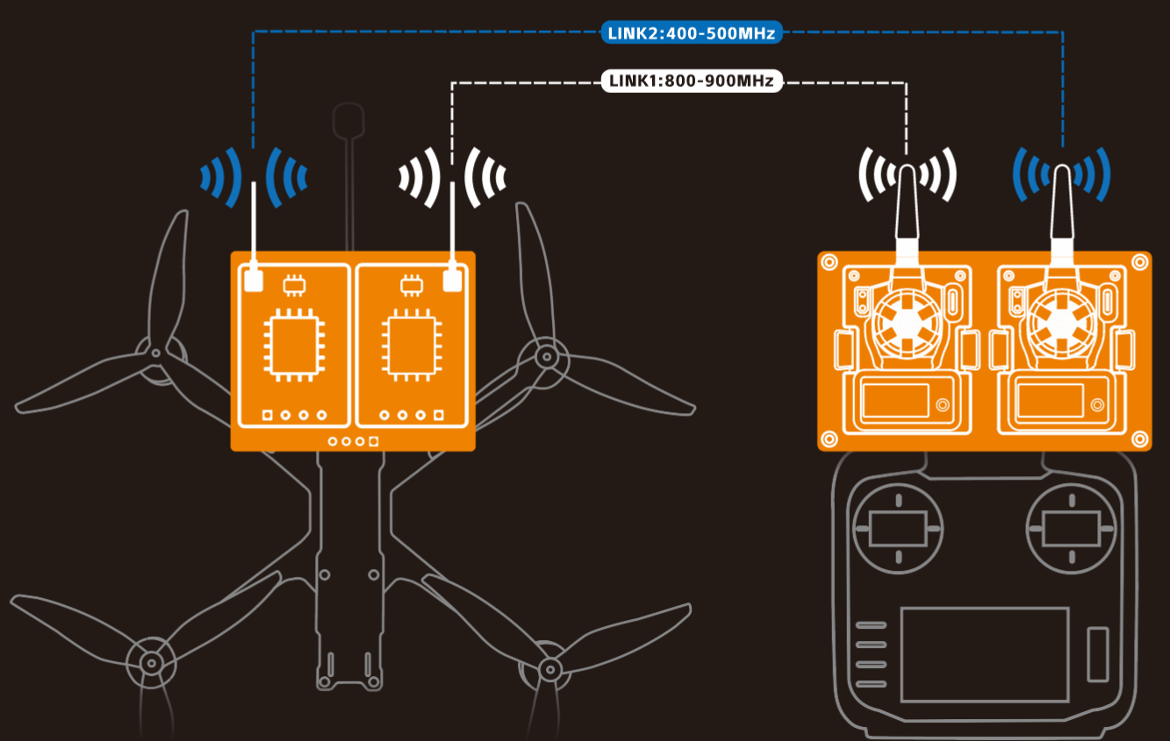

Transmitter Diversity Adapter
The connection between the Transmitter Diversity Adapter to Remote Controller is show as bellow:
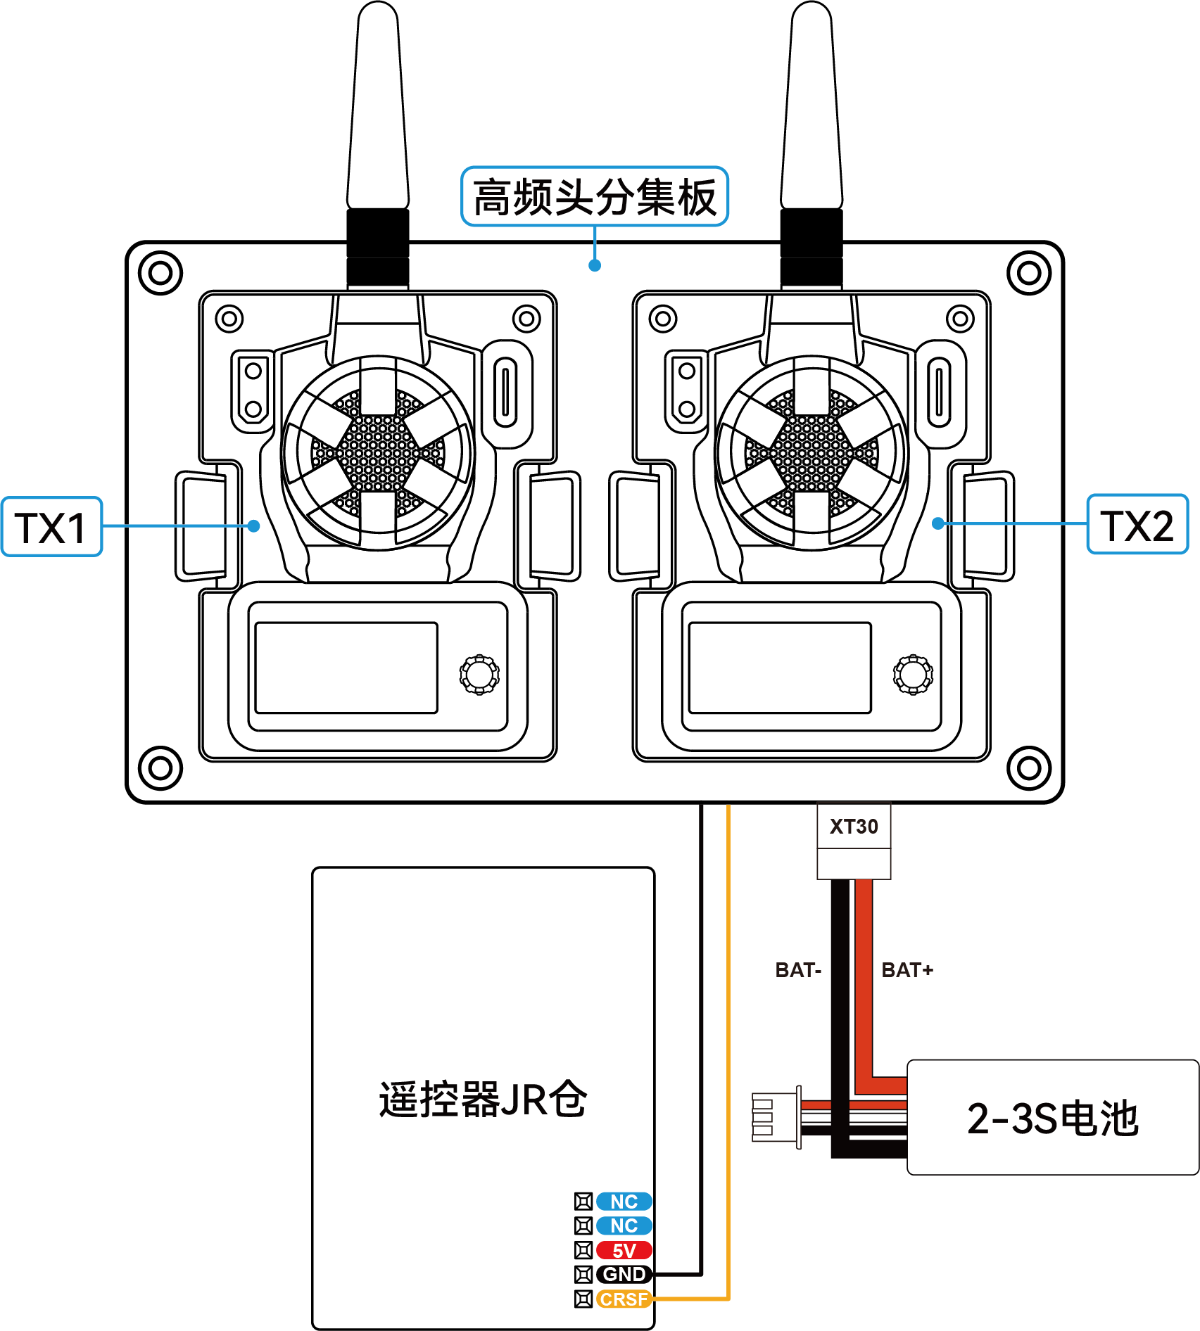

Instrucation for Transmitter Diversity Adapter:
- The remote controller must be configured in external RF mode.
- On the remote control, adjusted the CRSF serial port baud rate into 921K.
- Setting two transmitter with same telemetry rate, recommended to set both to 1:64.
- The packet rates of the two transmitter on the diversity adapter should not be higher than 250Hz.
- Power input range is 6-35V.（2-3S batteries are recommended）

Receiver Diversity Adapter
The connection between the receiver diversity adapter and the FC is show as bellow:
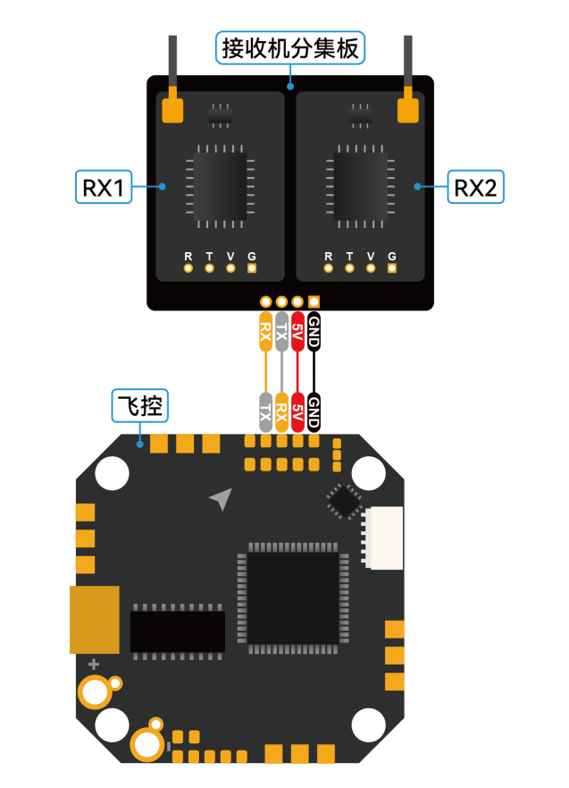

Instrucation for Receiver Diversity Adapter:
- Using the transmitter RF module to binding the receiver. Make sure that RX1 is successfully linked to TX1 and RX2 is successfully linked to TX2 . Do NOT use the remote controller to binding.

